
TOBB ETU
Economy & Technology University
BIL 495 / YAP 495
System Architecture Document (SAD)
Reference: IEEE 42010 / INCOSE SE Handbook 5th Ed.

Document Control Table
Document Title | Project Closure Report
Document ID | (To be assigned)
Prepared By (Author) | FinalStack
Reviewed By
Approved By
Preparation Date | 11.11.2025
Approval Date | 11.11.2025
Version / Revision | 1.0
Confidentiality Level | Restricted
Reference Standards | IEEE 15288, IEEE 12207, INCOSE SE Handbook v5

Change Record (Revision History Table)
Revision | Date | Prepared By | Reviewed/Approved By | Description of Change
1.0 | 11.11.2025 | FinalStack | FinalStack | Initial Release

1. Introduction
2. System Context
3. Architectural Views
3.1 Logical View
3.2 Process View
3.3 Physical View
3.4 Development View
4. Design Decisions
5. Compliance and Standards
6. Appendix
7. References

1. Introduction
Summarize purpose and scope of the architecture.
The architecture defines a secure, interoperable system that unifies all NICU data sources under standardized protocols such as HL7, DICOM, and FHIR.
It enables real-time data ingestion, AI-driven preprocessing, and clinical visualization to improve decision-making and patient outcomes in NICUs.
The architecture covers:
- Real-time acquisition and integration of NICU physiological, imaging, and clinical data
- AI-enhanced preprocessing pipeline for data cleaning, normalization, and standardization (HL7, DICOM, FHIR)
- Secure data storage and web-based visualization

2. System Context
Define the system boundary and external interfaces (context diagram recommended).
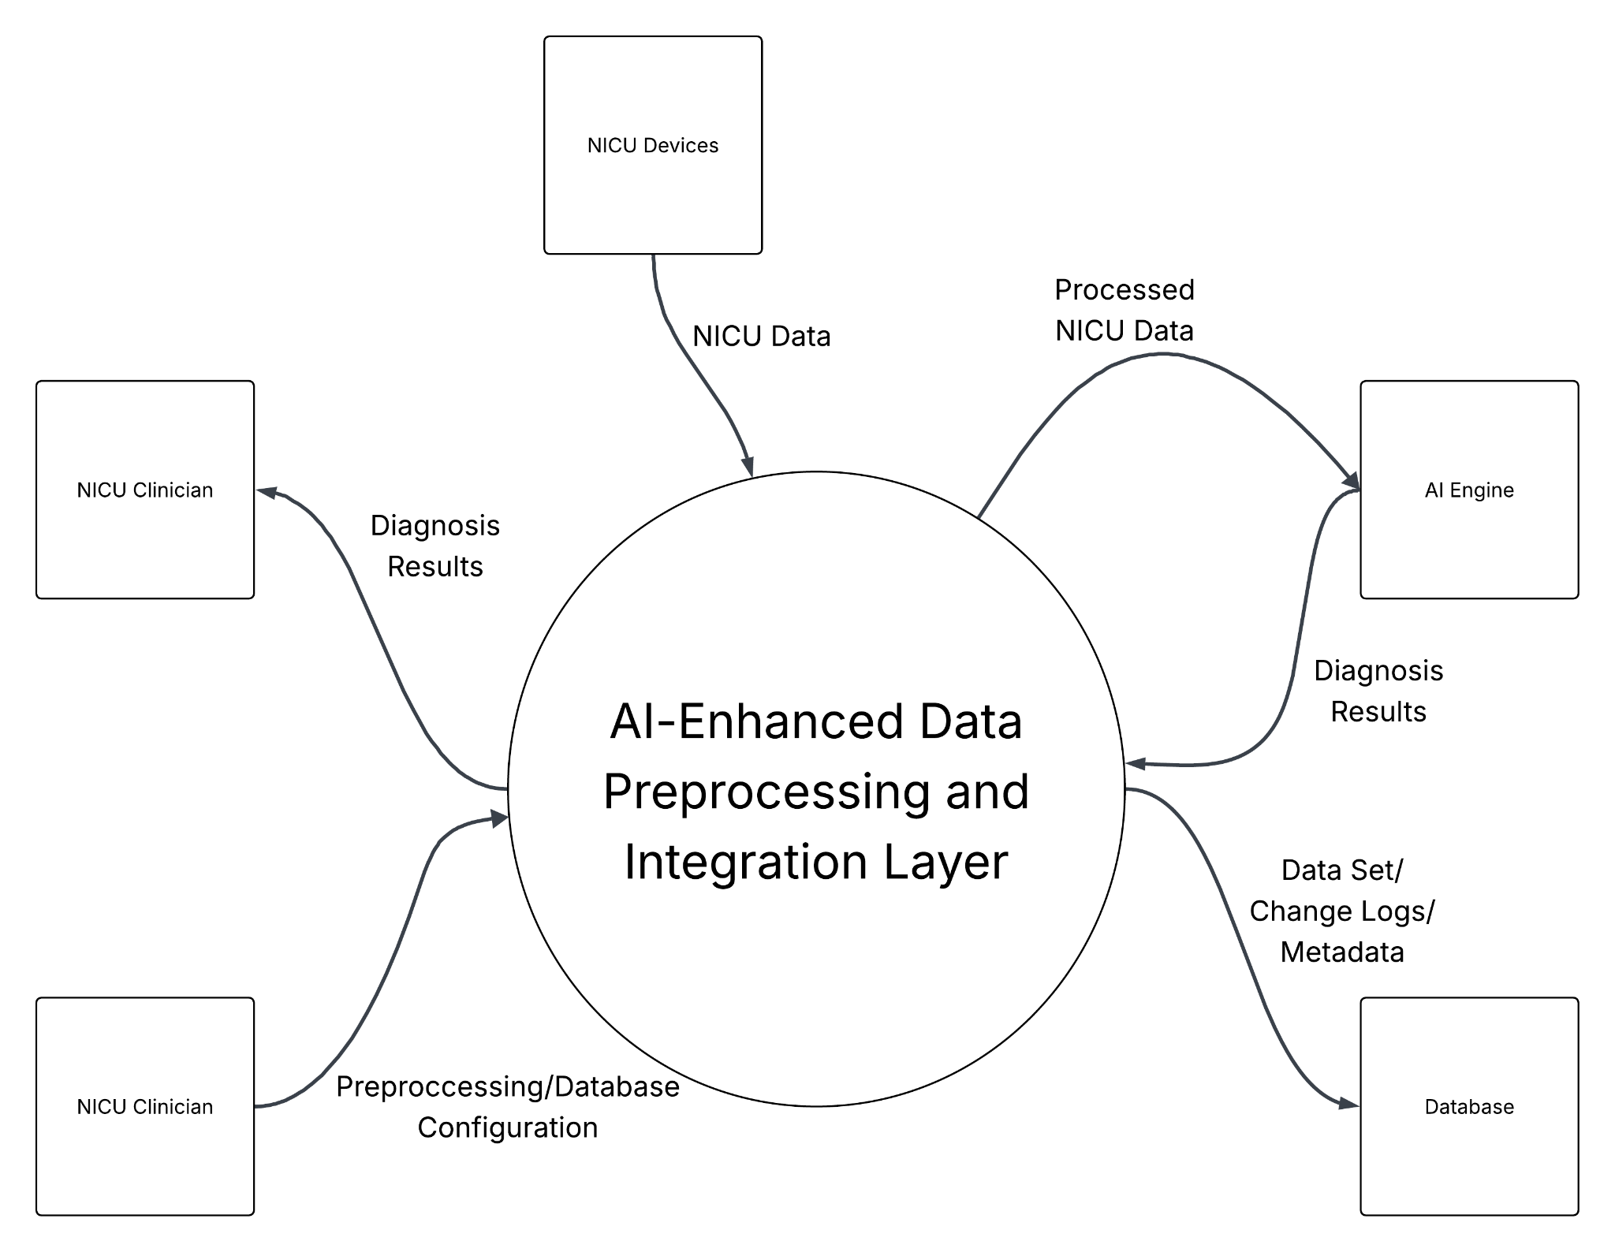

3. Architectural Views

3.1 Logical View
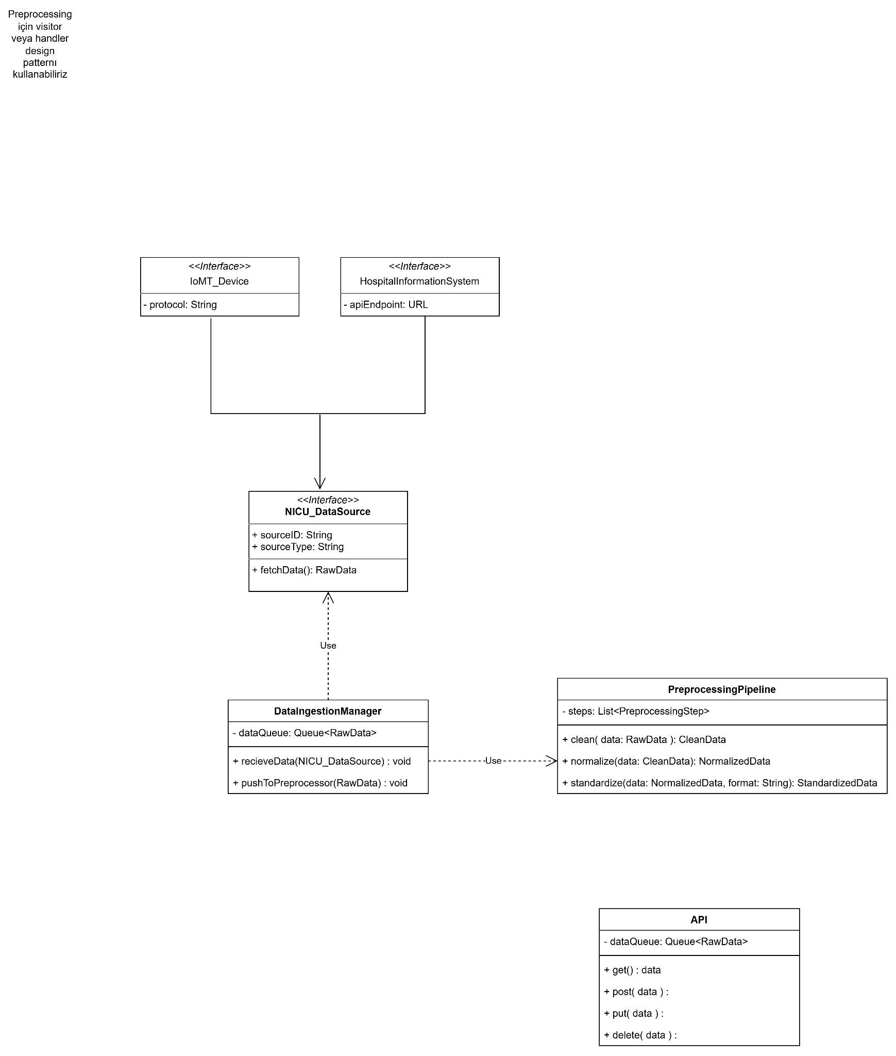
IoMT devices and hospital information systems act as data sources, feeding real-time neonatal data into the NICU_DataSource interface. The DataIngestionManager receives this input, queues the raw data, and sends it to the PreprocessingPipeline, where operations like cleaning, normalization, and standardization are performed. Once processed, the refined data can be accessed or transmitted via the API, which manages input and output through its internal data queue.

3.2 Process View
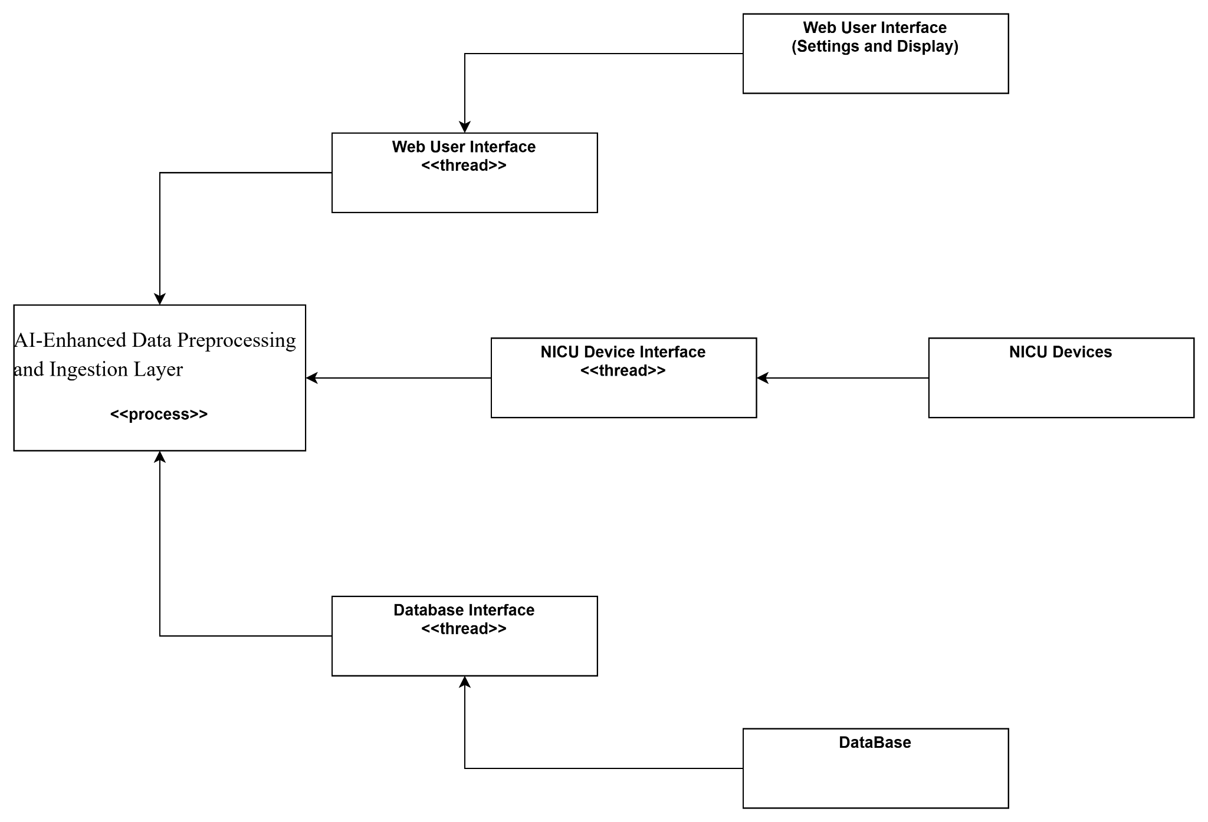
The AI-Enhanced Data Preprocessing and Ingestion Layer serves as the core process, receiving input from NICU devices via the NICU Device Interface and forwarding refined data to both the Database Interface for storage and the Web User Interface for visualization and control. The Web User Interface enables clinicians to configure system settings, monitor real-time data, and access diagnostic outputs, while the Database Interface ensures persistent data management for analysis and historical tracking. Overall, this process ensures a continuous, bidirectional data flow that connects device inputs, intelligent preprocessing, and user-facing applications within a unified operational framework.

3.3 Physical View
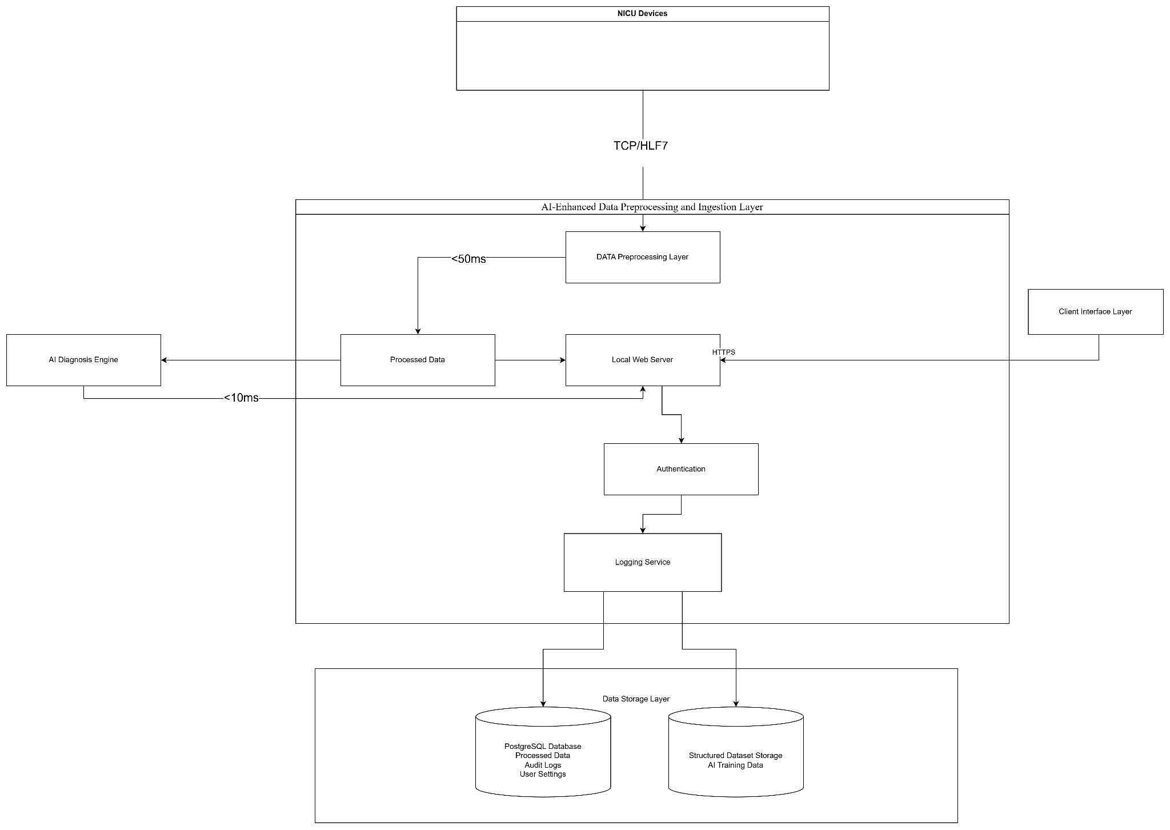
The NICU Device Layer comprises medical imaging devices, cameras, and sensors transmitting real-time neonatal data through IoMT gateways using HL7, DICOM, and TCP/IP protocols. These data streams are received by the Application Server, an x86-based system hosting services such as Data Ingestion, ETL Processing, and AI Model Interfaces. The AI Processing Layer executes Python-based diagnostic models, feeding processed results back to the Web Server for visualization. The Database Layer uses PostgreSQL for storing structured datasets, logs, and user configurations, ensuring auditability and data persistence. End users, including clinicians, AI engineers, and IT personnel, access the system through web browsers in the Client Layer, which communicates securely via HTTP and role-based authentication. This setup enables real-time monitoring, AI-driven insights, and robust data integrity across interconnected NICU subsystems.

3.4 Development View
TBD

4. Design Decisions
Layered Architecture was chosen because it enhances modularity, readability, and maintainability of the system. By clearly separating the responsibilities of each component, it allows easier debugging, testing, and future scalability without affecting other layers.
Event-Driven Architecture was selected to support real-time data processing with low latency and high performance. It enables asynchronous communication and loose coupling between components, which makes the system more responsive, resilient, and easier to extend as new event sources or services are added.

5. Compliance and Standards

Standard / Regulation | Description / Purpose | Applicability
GDPR (EU 2016/679) | General Data Protection Regulation. Ensures lawful, fair, and transparent processing of personal data in the EU. | Mandatory for all patient data handling, anonymization, consent management, and storage.
ISO/IEC 27001 | Information Security Management Systems (ISMS). | Used to guide secure data storage, access control, and risk management.
ISO/IEC 27018 | Code of practice for protection of personally identifiable information (PII) in public clouds. | Ensures cloud-based storage or processing components meet privacy protection standards.
HL7 (Health Level Seven) | International standard for transfer of clinical and administrative data between software applications. | Used for all clinical data communication and structuring of NICU sensor data.
DICOM (Digital Imaging and Communications in Medicine) | International standard for handling, storing, printing, and transmitting medical imaging information. | Applied to ensure interoperability for image data acquisition and processing.
FHIR (Fast Healthcare Interoperability Resources) | Modern HL7-based standard for healthcare data exchange. | May be used to enhance interoperability with hospital information systems and AI diagnosis modules.

6. Appendix

7. References

